The I(LxB) Force
and the

Ampere Unit
w/ the Current Balance
Sargent Welch—Cenco

Equipment Needed

Calipers, Digital, Mitutoyo 500-474
Power Supply, Elenco XP-800
Laser, HeNe ~670nm
Power Supply, Laser HeNe
Jack, Table Silver
Ruler, 12-15in
Tape Measure, 5m Stanley 33-158
Mass Set, Fractional Ohaus 292-01
Meter stick
Ring stand, 135cm w/ meter stick
Compass (Optional-Tables are marked)
Coulomb & Current Balance, SgtW (CP23530) Cenco Set up with current rods
Leads, Special Built in Coul/Cur Box
Multi-Meter, Digital (DMM) Wave Tech 15XL Class

The Current Balance Setup
w/ Associated Equipment
Figure 1
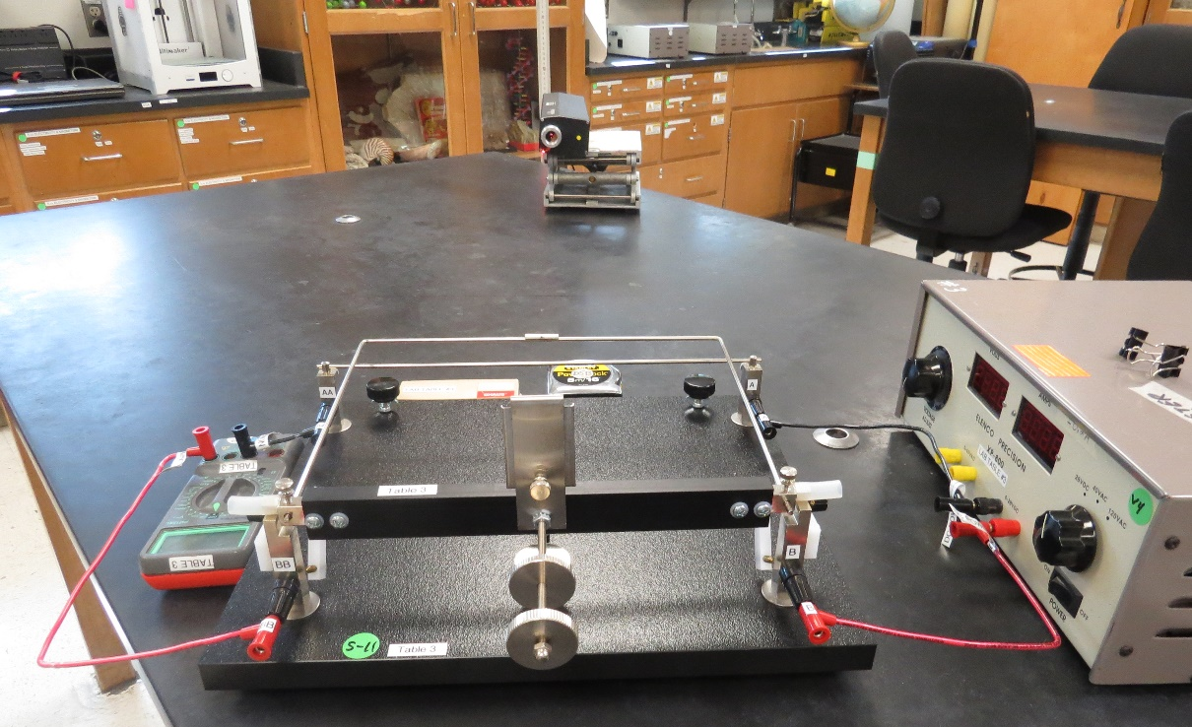

Introduction
In this lab we will explore the force that exists between two current carrying conductors and how this force is used to define the ampere. Even though charge is a more fundamental type of quantity than current, practically measuring the net charge of some object is very difficult. We can much more easily measure currents, and for that reason the ampere and not the coulomb has been chosen as the fundamental unit in the SI system of units. The coulomb then is a derived unit and is defined as:
Equation 1
To understand how the ampere is defined, we need to understand the force that exists between two current carrying conductors. As discussed in class, two parallel wires carrying currents exert forces on each other. Each wire carries a current which we denote and respectively. There will be a force on the first wire due to the magnetic field of the second wire and a force on the second wire due to the magnetic field of the first wire. We can calculate the force on each of the wires by first calculating the magnetic field and then using the expression for the force on a wire
Equation 2
The magnitude of the magnetic field, B, at a distance r from a long, straight wire carrying a current is
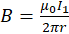 Equation 3
The force on a wire of length L carrying a current a distance d from the first wire due to the magnetic field of the first wire is
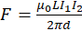 Equation 4
If the current flows in the same direction, we can show using the right hand rule that the force is an attractive force between the two wires. If the current flows in opposite directions in the two wires, then the force between the wires will be repulsive.
Often we like to consider this force between the wires without having to consider the length of the wires. We obtain the force per length of wire simply by dividing the length out of the expression for the force. The force per length is given by
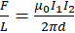 Equation 5
The ampere is defined in terms of the force per length on a wire. A current of 1 ampere is that current which, if present in each of two infinitely long, parallel conductors, located one meter apart in a vacuum, would produce a force per length in the wires of exactly .
The definition of the ampere in turn defines the value of .
Where
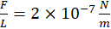 Equation 6
Equation 7
Note: Since, , we can use .
Equation 8
Substitution using Equations 5 & 6, we can solve for obtaining
. Equation 9
We will now use essentially the same apparatus that we used to find . As an aside, determining these two constants ( and ) allows us to determine the speed of light, a point which we will discuss in some detail later this semester.
In our experiment we will determine the force between two wires of length L separated by a distance d each carrying a current I. Thus, Equation 4 can be written:
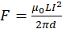 Equation 10
Solving for , we get
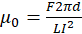 Equation 11

Setup
- Setup will look like Figure 1 on Page 1. A schematic of the layout is shown in Figure 2.
Figure 2 Schematic of Setup
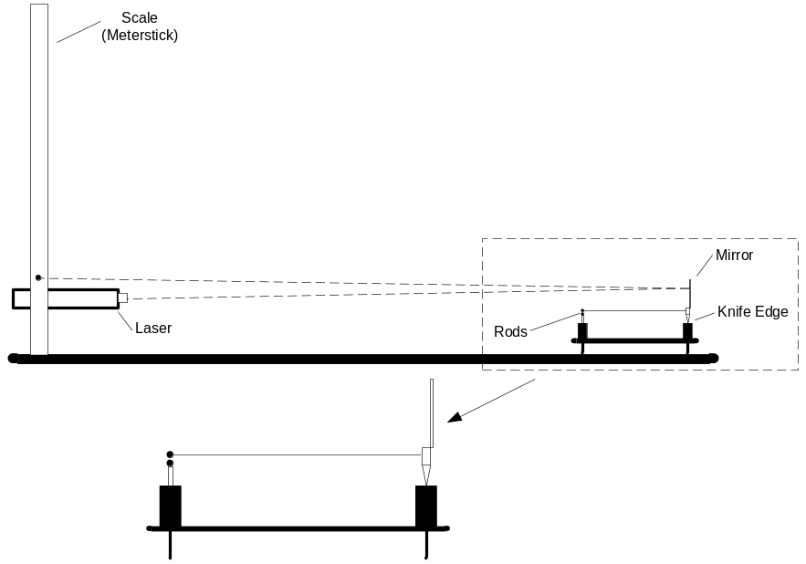
There are protective covers on the knife blades. They must be removed at this time and placed in the apparatus box.
- A box (cardboard, not shown) has been provided. The box is important to deal with air current effects due to the sensitivity of the apparatus.
- The earth’s field can affect results. This can be alleviated by orienting the two conducting rods parallel to the earth’s field as shown in Figure 3.

Figure 3
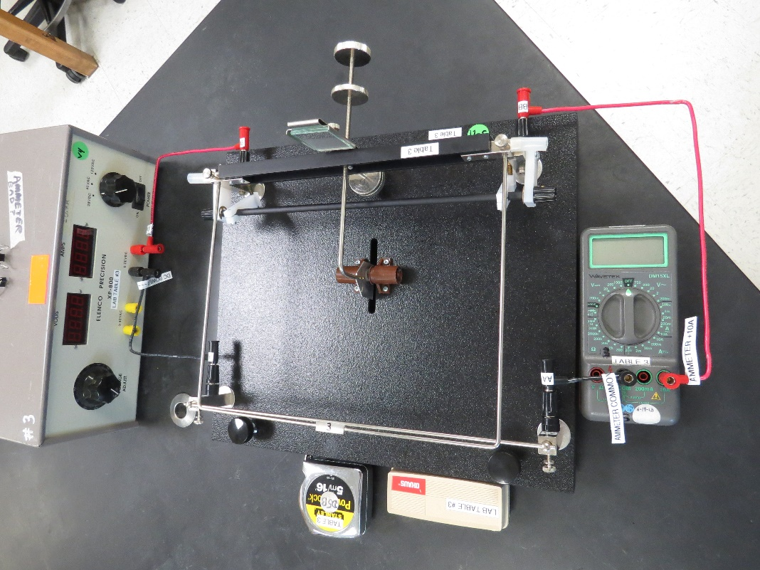
- The wires for the setup have been pre-shaped to plug straight in. There should be minimal adjustment necessary. The circuit should be wired as in Figure 4.
Figure 4 Schematic of Apparatus Wiring
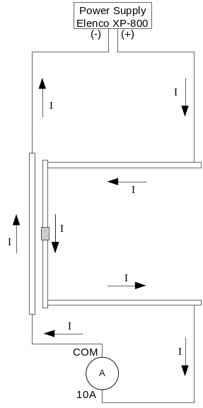
- Make sure the conducting rods are parallel. (Stationary and pivoting.) To do this, place a coin in the tray pushing the conducting rods together. Adjustment is done by moving the lower conducting rod at one end or the other. They should also be aligned vertically. This adjustment is done at the pivot bar.

Safety
Although these lasers are not particularly dangerous, we should take a few simple precautions to prevent the unlikely event of eye damage.
- Never look directly into the laser beam. Laser light has a high intensity and can also be easily focused. A direct shot of the laser beam on your eye will be focused by your cornea onto a small spot on your retina and can burn or possibly detach the retina.
- Never hold a reflecting object by hand in front of the laser beam. This prevents the possibility of accidentally shining the light into your eyes.
- Keep your head above the plane of the laser beam.
- Whenever the light strikes an object, there will be a reflection. At times the reflections can be almost as strong as the incident beam. Know where the reflections are and block them if necessary.
- The laser has a shutter in front of the beam. When not taking data, place the shutter in front of the laser beam.
Procedure
- Take preliminary measurements. Distances a, b, and L can be measured directly as shown in Figure 5.
- Set the bars a small distance apart using the counterbalance. This distance is arbitrary. (. The counterbalance under the beam can used to limit oscillation of the bars. Oscillation should be limited, 1 to 3 seconds if possible.
Figure 5 Dimension Measurements
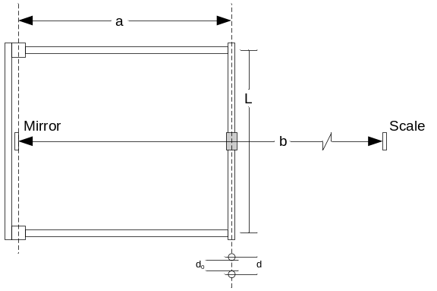
- Find d. This is the separation of the bars, center to center. This is an optical lever as illustrated in Figure 2. An optical lever consists of a laser, a mirror, and a scale to detect the position of the laser beam. The mirror is attached to the support of the upper wire in the current balance. When the balance is deflected through an angle , The mirror is also deflected through an angle . Consequently, the beam will be deflected through an angle .
Measurements a and b were taken in Step 1 as shown in Figure 5.
Record the location of the laser spot on the scale, this will be considered the equilibrium point. Place a coin on the pan of the top bar. Record the location of the laser spot. The difference of the two readings is D.
For small angles
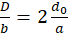 Equation 12
To accurately determine the distance between the wires, simple geometry will give Equation 13.
For
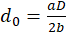 Equation 13
Now d, the center to center distance, can determined:
Equation 13
- Place a weight on the tray. Start with 20mg.
- This will bring the bar downward.
Do not handle the masses with your fingers. Use the tweezers. Always replace the spacing bar and close the mass box when not removing or replacing weights.
- Turn on the power supply. Slowly increase the current until the laser pointer returns to the equilibrium position. The force of repulsion between the two rods is now the same as the weight of the 20 mg mass. Record your values of mass, m, and current, I in Table 2.
- Add more weights, incrementally (20mg), to the pan and bring the pointer back to equilibrium. Recording each set of data.
Warning: Do not allow the amperage to reach 10 A. If you can reach 9.8 A or 9.9 A don’t go any higher. If you accidentally exceed 10 A on the indicator immediately crank the control down. Failure to do so will probably blow the fuse and/or damage internal components of the unit.
- When you a have reached a weight that can’t be brought back to equilibrium under 10A, you’ve collected as much data as possible.

Table 1: Preliminary Data
Distance from Mirror to Conductor
Distance from Mirror to Scale
Length of the wire that carries current
Change in laser spot position from closed to equilibrium
Wire-gap Distance
(Calculated)
(Measured)
(the center to center distance)

Table 2: Current/Force Data
Mass | F  N | Current in wires  A | Calculated Value of 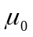  (using Equation 11)

Questions
- Show an example calculation of .

- Consider the values of that you calculated in Table 2. Which value was closest to the accepted value? Why do you think this data point was closer than the others? Which data point was furthest from the accepted value? Discuss the experimental problems that most affected this value. Why were these problems more pronounced for this value?

